Real Property Holdings Owned by the Hospital (HB 321)

Location | Parcel ID Number | Estimated Size | Purchase Price | Current HealthCare Purpose? |  | Improvements? |  | Notes  (Optional)
 |  |  |  | Yes | No | Yes | No
117 Kite Rd, Swainsboro, GA 30401 | S35 018 |  | UNK | X |  | X |  | Main Hospital
625 W Church St, Swainsboro, GA 30401 | S35 010 | .86 Acres | $125,000 |  | X |  | X
118 Powell St, Swainsboro, GA 30401 | S35 012 | 1 Acre | $120,000 |  | X |  | X
Hwy 57, Swainsboro, GA 30401 | 076 053 | 6.51 Acres | $315,000 |  | X |  | X
501 Church St, Swainsboro, GA 30401 | S35 040A | .82 Acres | $244,500 | X |  |  | X
Victory Dr, Swainsboro, GA 30401 | S35 040B | .55 Acres | UNK | X |  | X
543 W Church St, Swainsboro, GA 30401 | S35 041 | .23 Acres | UNK | X |  | X
115 Gillikin St, Twin City, GA 30471 | T02 055 | .8 Acres | $330,000 | X |  |  | X
S Railroad Ave, Twin City, GA 30471 | T02 060 | .29 Acres | $6,500 | X |  | X
120 Victory Drive, Swainsboro, GA 30401 | S35 039D | .65 | $100,000 | X |  |  | X
Date: _9/19/19_______.
Revised: ________________.

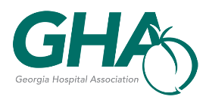
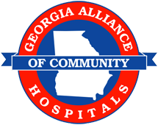

Location may be the county, address, or site identification/description.
Purchase price to be listed as of the date of acquisition of the property by the hospital, if known. If unknown, state “UNK”.
Health care purpose includes the provision of patient care; the provision or delivery of healthcare services, including supportive administrative services; the training and education of physicians, nurses, and other healthcare personnel; and community education and outreach relating to health care or wellness.
Improvement means the permanent addition or construction of a building or structure.

